1. Select the last day of the present month.

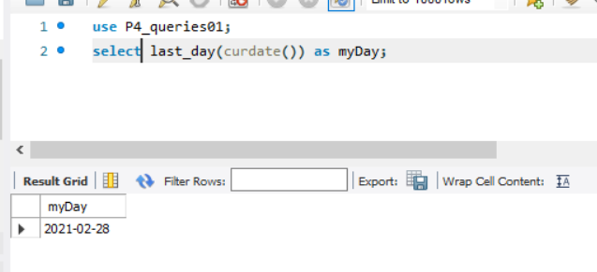

2. Select the last day of the month three months before today.

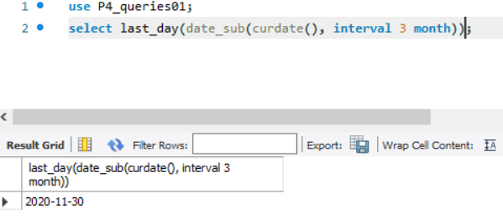

3. Show the date of exercise 2 with format “Name_of_month day, year with 2 digits”.

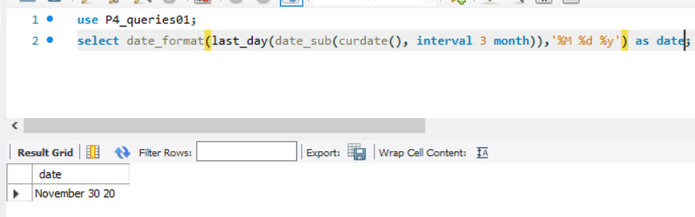

4. Write a query to convert 680001 days in a date.

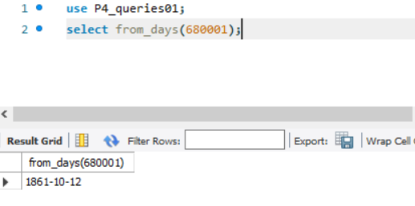

6. Use CONVERT_TZ to convert the current date/time (UTC) to Panama. Clue: Visit this [link](https://mariadb.com/kb/en/library/mysqltime_zone_name-table/)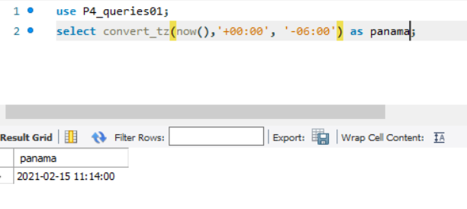

7. Use CONVERT_TZ to convert the current date/time (UTC) to Sydney. Clue: Visit this [link](https://mariadb.com/kb/en/library/mysqltime_zone_name-table/).

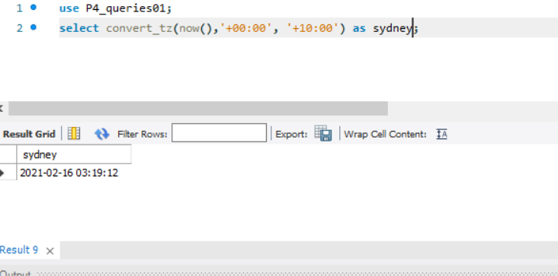

8. Subtract 3 hours 25 minutes to the current date/time using DATE_SUB.

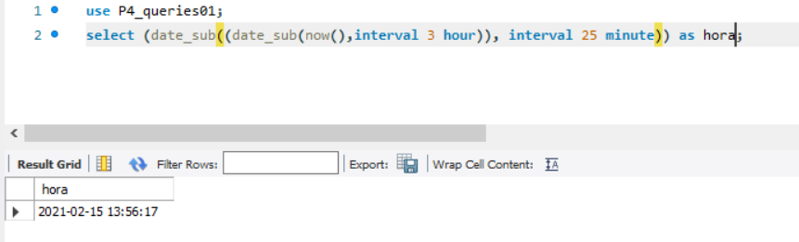

9. Which day of the year (1, 2, 3, etc., 365) is today (example for 31-01-2019 not for today)?

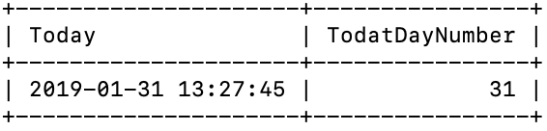

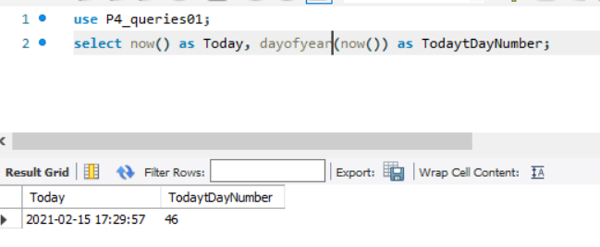

10. Can you convert a String to a Date and/or Time? Write an example.

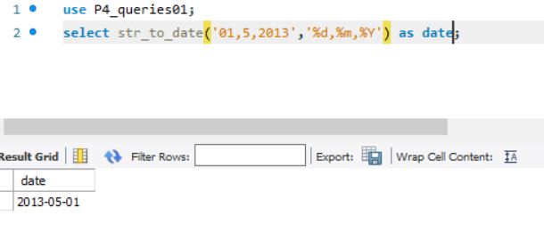

11. Search on the Internet what’s a period and make an example using the function PERIOD_ADD.

Es una partida de tiempo.

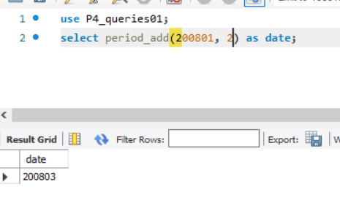

12. Difference in days between the employee who started in the first place and the employee who started in the last place.

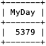

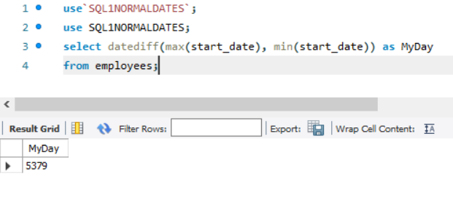

13. Select the dates inside the field EMPLOYEES.start_date that are Tuesday.

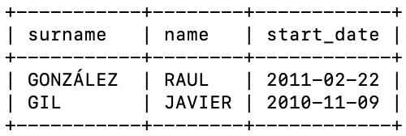

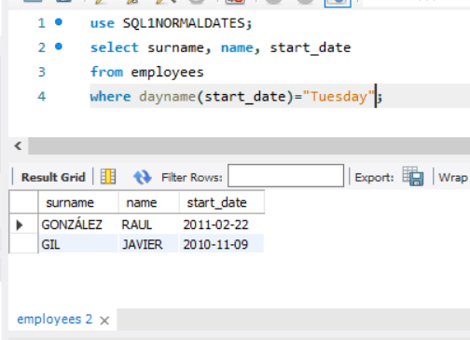

14. Select the data of the older employee in the enterprise.

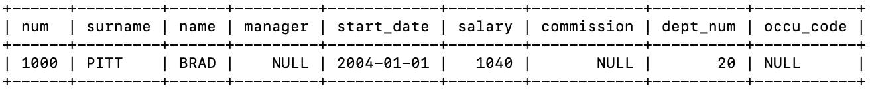

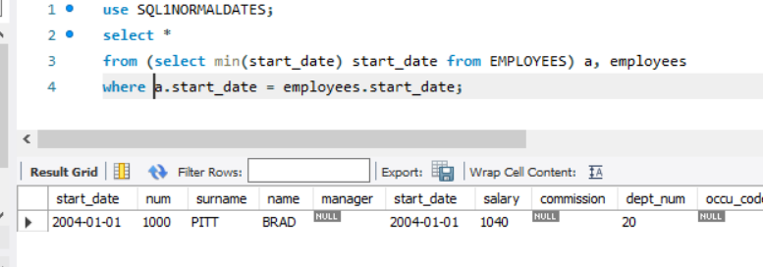

15. Select the employees’ name, surname and years working in our enterprise (order by those years descendent).

|  |  |
| --- | --- |
| Option 1: | Option 2: |
|  |  |

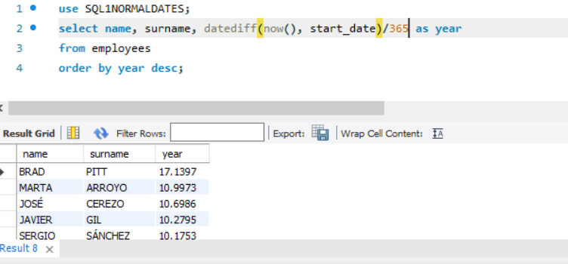

16. Write a query to show EMPLOYEES.start_date in three columns: year, month and day.

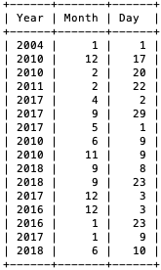

7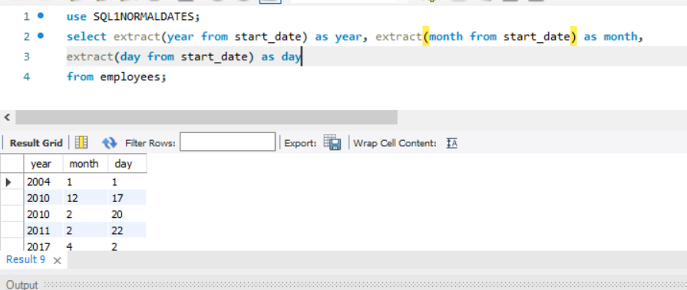

17. Write a query to show the employees that joined the enterprise in June.

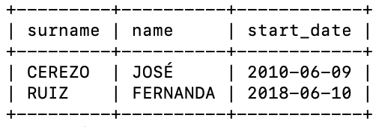

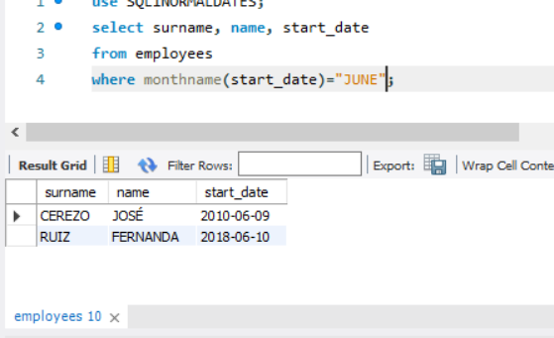

18. Write the date of exercise 17 in the next format:

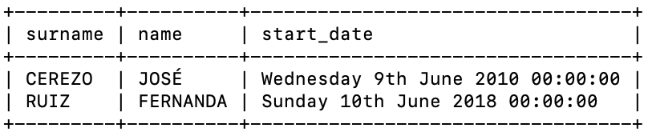

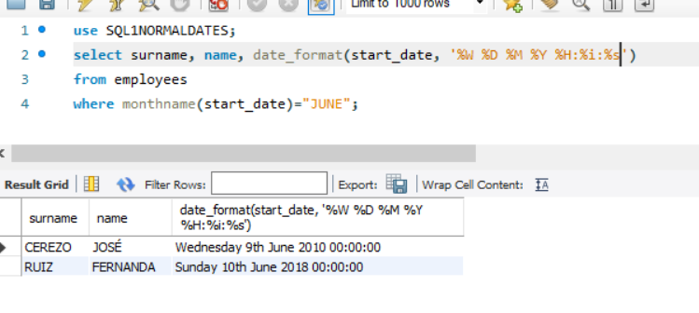

19. Write a query to get the year and number of employees who began working that year.

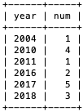

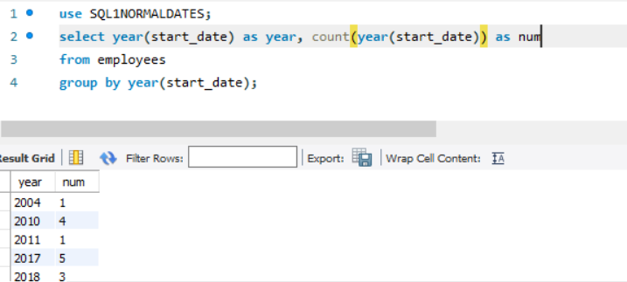

20. Write a query to get the maximum number of employees who started working in our enterprise in a year.

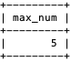

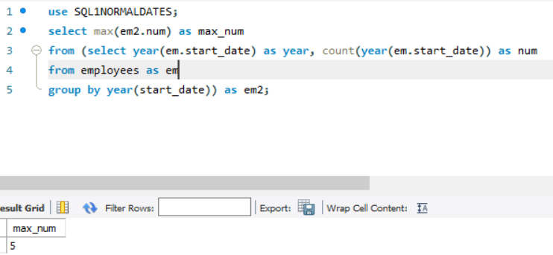

21. Write a query to get the year in which more employees joined our enterprise.



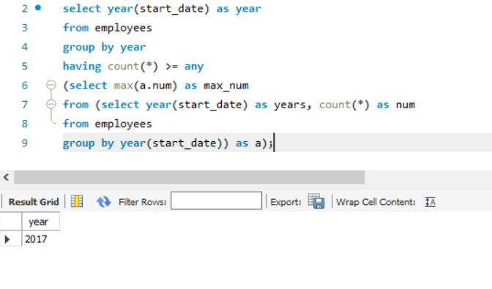

22. Show employees who are manager of other employees and the time in years that they are working in the enterprise.

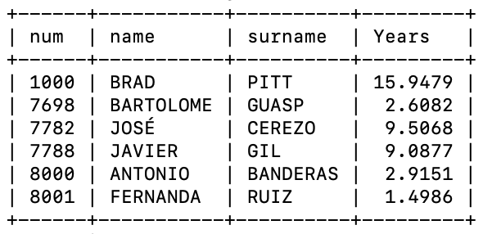

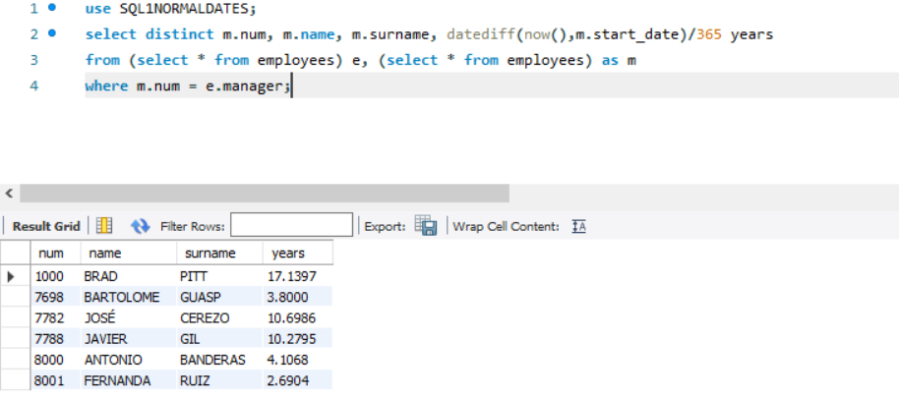

23. Show employees who are manager of other employees working in the enterprise for more than 5 years.

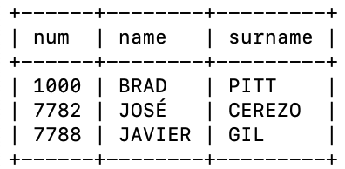

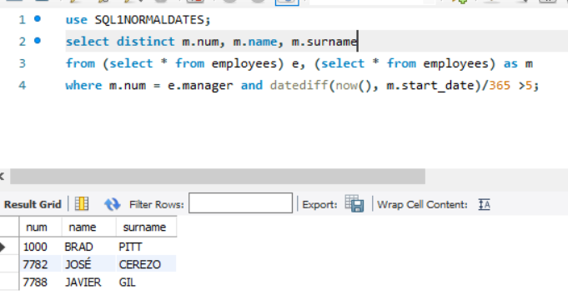

24. Can you use BETWEEN keyword with dates. Write an example.

